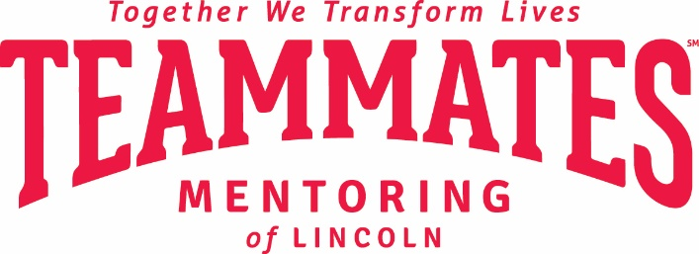

Dear Parent and/or Guardian:

As your student’s mentor, I would like to invite you and your student to attend the annual TeamMates Recognition Event with me:
Thursday, February 8, 2018
5:30 p.m. to 7:30 p.m. (doors open at 5:00 p.m.)
Lincoln Station, 201 N. 7th Street

This annual free event recognizes the accomplishments of TeamMates mentors, mentees, facilitators and community supporters. TeamMates relies on in-kind donations to be able to provide this fun, inspiring evening for students and their mentors. The evening will feature a buffet dinner provided by Premier Catering, awards ceremony and keynote presentation by former Husker and current Washington Redskins linebacker, Will Compton.

This is a very popular event and seating is limited. Three seats are allotted on a first-come, first-serve basis, and only to matches with completed paperwork. The three seats are for mentor, mentee (student), and a third party. The third party can be a student’s parent/guardian or another adult family member (18 years or older).

If your student would like to attend, the attached Meeting Outside of School Plan Form will need to be signed by you (parent/guardian) and returned to your school’s TeamMates facilitator by February 1.

If you are unable to attend, but another family member (18 years or older) would like to attend with your student, they will need to sign the attached Third Party Image Release Form. Please return this completed form to your school’s TeamMates facilitator by February 1.

I will register all of us for the event as soon as the signed forms have been received. If you have any questions about the necessary forms or the Recognition Event, fee free to contact the TeamMates office at 402-436-1990.

I will let your student know when our seating has been confirmed by the TeamMates office.

I look forward to being able to spend this celebratory time with you and your student.

Sincerely,

